Syed Nasif Ali (201304650)

Lab 2: Exercise

<https://studio.code.org/s/course4/stage/6/puzzle/5>

set length – 100

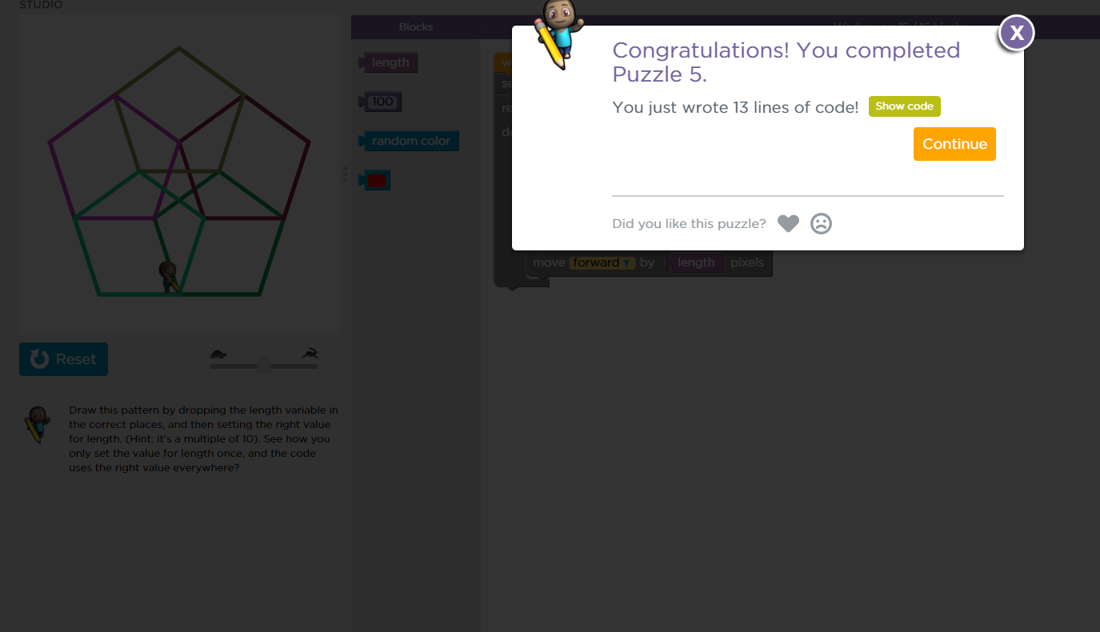

<https://studio.code.or/s/course4/stage/6/puzzle/6>

set width – 100

width \* 2

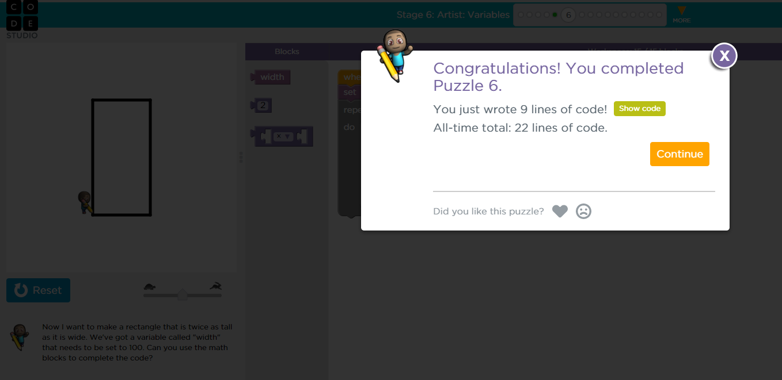

<https://studio.code.org/course4/stage/6/puzzle11>

set side – 4

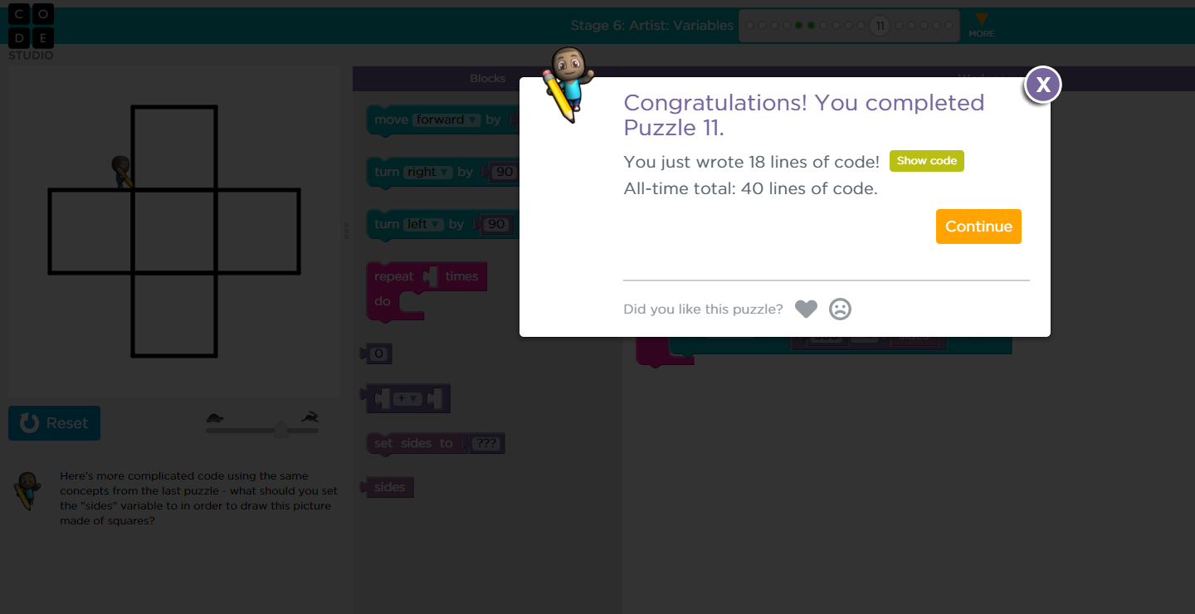

<https://studio.code.org/s/course4/stage/6/puzzle/12>

set side – 75

Angle is common

<https://studio.code.org/s/course4/stage/6/puzzle/14>

Observed

